Investment Committee Newsletter - October 2025
The Investment Committee team presents its October 2025 newsletter, where we share insights surrounding the Capital Pool and Nexus Mutual's investments. The goal is to make key data transparent and easily accessible to everyone.
State of the Capital Pool
Monthly Change - ETH value
The Capital Pool decreased by 4.61% in ETH terms this month, from 49.5k to 47.3k ETH. Withdrawals through the RAMM, which totaled 2.7k ETH in redemptions, were the primary factor in this decline. A positive stablecoin FX impact, Cover Fee income, and Investment returns all contributed positively but were not sufficient to offset the outflows.
The various impacts on the capital pool are summarised in the waterfall chart below.
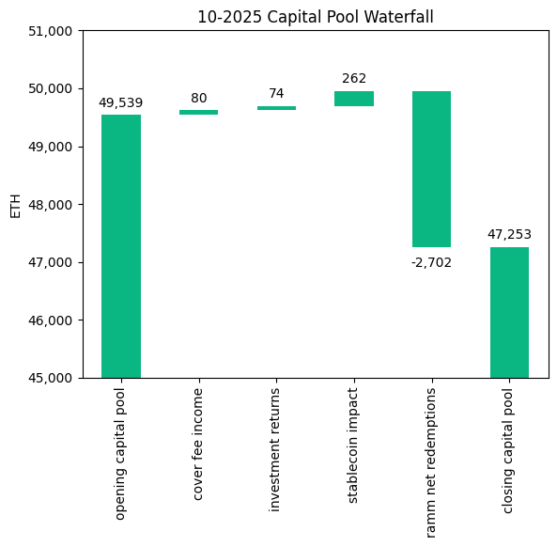
The cover fee income is net of distribution commissions and excludes covers paid for in NXM. In such a case, the cover fee gets burned and there is no change in the Capital Pool.
Monthly Change in NXM Book Value
The Capital Pool's ETH/NXM value rose from 0.023885 to 0.024108, representing an 11.7% annualized increase for the month. This growth was primarily driven by the positive stablecoin FX impact, with additional contributions from RAMM activity and investment returns.
The various impacts on the capital pool are summarised in the waterfall chart below.
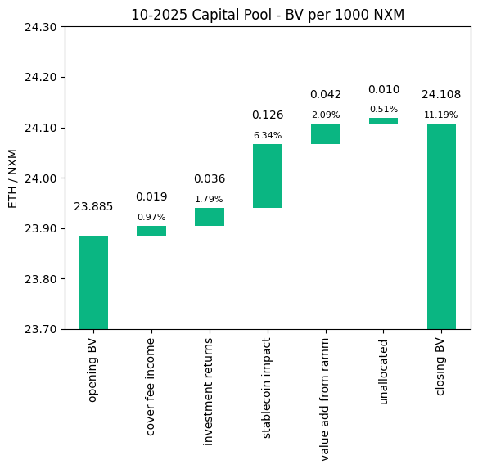
→ Members can track protocol’s revenue on the Financials Dune Dashboard
→ Members can track in/outflows on the Ratcheting AMM Dune Dashboard
→ Members can track the cover income on the Covers Dune Dashboard
End of Month Pool Split
The split of the Capital Pool at the end of Oct '25 in ETH terms is as follows.
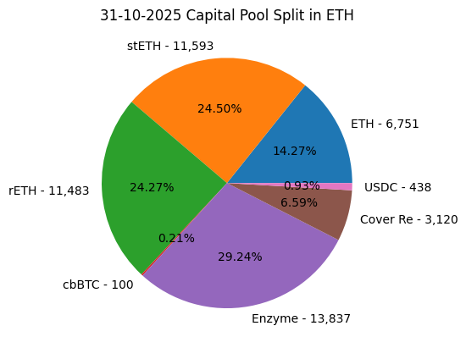
→ Members can find the updated split at any time on the Capital Pool and Ownership Dune Dashboard
State of the Investments
In the last month, the Mutual earned 73.9 ETH on its investments, overall, as broken down below.
stETH Monthly Return: 30.286
stETH Monthly APY: 2.834%
rETH Monthly Return: 24.387
rETH Monthly APY: 2.583%
Enzyme Vault Monthly Return: 19.265
Enzyme Vault Monthly APY: 1.539%
Enzyme Vault includes EtherFi investments
Total ETH Earned: 73.939
Total Monthly APY: 1.848%
Based on average Capital Pool amount over the monthly period
All returns after fees
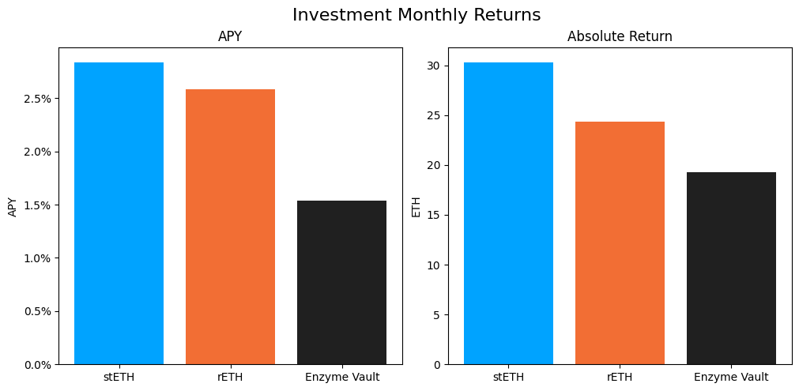
Active staking investments yielded between 1.5% and 2.8% APY this month, reflecting healthy ETH staking returns. Overall, based on the average Capital Pool value for the month, investments returned 1.8% APY.

